**Tedence Setup**

The Tedence device setup involves the use of multiple Extremely Low-Frequency Electromagnetic Field (ELF-EMF) sensors strategically placed on the patient's body and within the environment to capture relevant electromagnetic data. Specifically, two Nivio sensors are strapped to the right forearm, one Migne sensor is strapped to the left forearm, one Nivio sensor is placed in the room as a background reference, two Nivio sensors are mounted inside a bicycle helmet worn by the patient, and two Nivio sensors are strapped over the right upper quadrant (RUQ) of the abdomen.

Each pair of sensors is connected to a TDK-provided motherboard, which is wire-connected to a Data Acquisition (DAQ) card, the NI PCIe-6251, featuring 16 Analog Inputs (AI), 24 Digital Inputs/Outputs (DIO), and 2 Analog Outputs (AO). This DAQ card is interfaced with a desktop PC, specifically a Lenovo ThinkCentre Neo 50t, equipped with an Intel i5-12400 processor, 16GB RAM, 512GB SSD, and running Windows 11 Pro.

Data collection is managed using standard LabVIEW software. The collected data is then transferred to Google Drive for storage. Subsequent analysis of this data is conducted by Evolution Inc., employing advanced AI algorithms to correlate the electromagnetic signals with glycemic events, facilitating accurate prediction and management of these events.

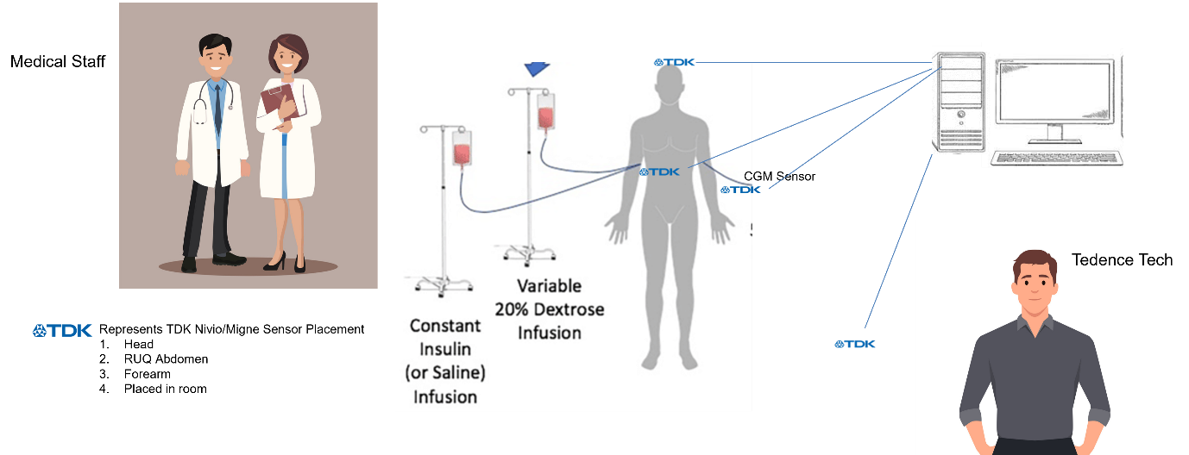

**Operating Instructions and Functional Test**

**Operating Instructions**

1. **Setup and Connection:**
   * Connect each pair of sensors (Nivio and Migne) to the TDK-provided motherboard.
   * Connect the motherboard to the NI PCIe-6251 DAQ card using the appropriate wires.
   * Ensure the DAQ card is properly installed in the Lenovo ThinkCentre Neo 50t desktop PC.
2. **Power On:**
   * Power on the Lenovo ThinkCentre Neo 50t desktop PC and ensure it boots into Windows 11 Pro.
   * Launch the LabVIEW software on the PC.
3. **Initial Calibration:**
   * Within the LabVIEW software, select the initial calibration mode to ensure all sensors are recognized and properly configured.
   * Follow the on-screen prompts to complete the calibration process.
4. **Functional Test:**
   * Begin the functional test by moving each of the sensors randomly in all directions (up, down, left, right, and rotational) to ensure they are responsive.
   * Observe the real-time data in LabVIEW to confirm that each sensor is capturing signals accurately.
   * Check for any discrepancies or irregularities in the signal readings during movement.
5. **Recording Test:**
   * Ensure the samples per second rate is set by a Tedence technician.
   * Activate the recording element within LabVIEW to start capturing data.
   * Move the sensors again in various directions to ensure that the recording functionality is operational.
   * Verify that the data is being recorded correctly by checking the recorded signal logs.
6. **Attaching Sensors to the Patient:**
   * Once the functional and recording tests are complete and all parameters have been verified, attach the sensors to the designated positions on the patient’s body:
     + Two Nivio sensors to the right forearm.
     + One Migne sensor to the left forearm.
     + Two Nivio sensors inside the bicycle helmet worn by the patient.
     + Two Nivio sensors over the right upper quadrant (RUQ) of the abdomen.
     + One Nivio sensor placed in the room as a background reference.
7. **Data Collection:**
   * Begin the data collection process with the sensors attached to the patient.
   * Monitor the data in real-time using LabVIEW and ensure continuous recording.
8. **Data Transfer and Analysis:**
   * Once the data collection session is complete, transfer the recorded data to the designated Google Drive storage.
   * Ensure the data is securely uploaded and accessible for subsequent analysis.
9. **Shut Down:**
   * After verifying that all tests and data collection are successful, deactivate the recording function in LabVIEW.
   * Properly shut down the Lenovo ThinkCentre Neo 50t desktop PC.

**Notes:**

* All connections and system tests should be performed and verified before applying the sensors to the patient.